**Robotics I – Project 4 Fall 2019 – Due Wednesday Oct 2, in class**

**Line and Circle Following**

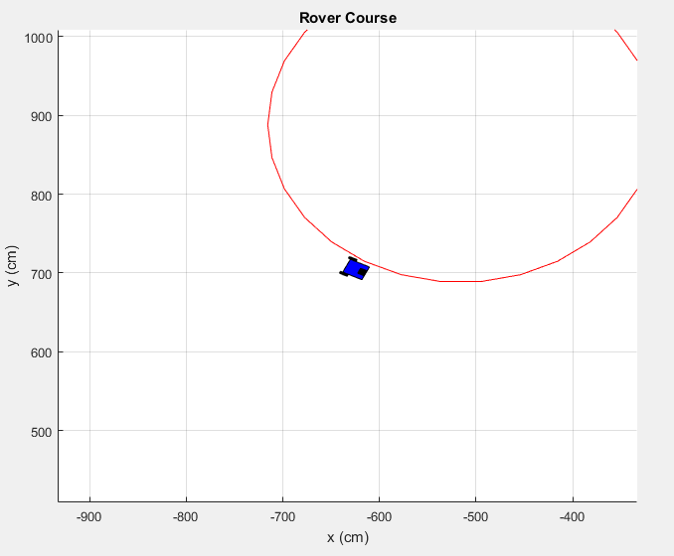

**Project Assignment: Develop and implement code to steer our rover in order to follow a pre-defined line and then develop and implement code to steer our rover around a circle (both given a fixed velocity which has been set). There are two TODO sections**

1. **Modify the code in the FollowLine.m function in order to set the angular rotation rate (w) of the rover in order to follow the line defined and sent to the function.**
2. **Modify the code in the FollowCircle.m function in order to set the angular rotation rate (w) of the rover in order to follow the circle defined and sent to the function given the input lambda (ccw or cw).**